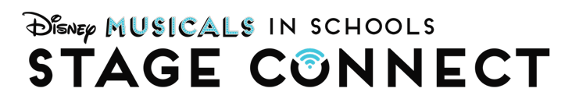

FINALIST VIDEO SUBMISSION

Finalists will be selected mid-March and will be asked to submit a video essay in late March. If this period is busy for your team, you may consider recording early in the hope you will be selected to move to the next round. These video details are provided in a Word format so that you may write responses, thoughts, or plans to help your team planning.
Finalists will be notified March or April 2026 and provided with further instruction.
---

Please record a 5 – 10 minute video that includes your ENTIRE School Team (minimum of 4 people) and a member of your administration (ideally Principal and/or Assistant Principal). Everyone should speak and as a team, be sure to answer all provided questions.

The creativity and format of the video presentation will not be scored, only the content. If it’s challenging to gather everyone in a single space, feel free to use a video call to record your conversation.

In 10 minutes, the video submission should address the following points:
- From School Team:
  - Each team member should
    - Introduce themselves and share their job title at the school
    - Share what they imagine their role in the production would be (Director, Choreographer, Music Director, Stage Manager, Producer, Production Manager).
    - Share what are you hoping to gain from the professional development that Stage Connect offers?
  - What steps will you take to continue doing theatre with your students after year 1 of this program?
  - Producing a school musical is a large time commitment. How will your team balance this project with your required job duties?
  - Musical Theatre is a collaborative art form that offers a unique opportunity for team teaching and modeling positive collaboration for students. How will your team approach team teaching and collaboration?
- From Administrator:
  - Introduce themselves and share their role at the school
  - How do you intend to support your School Team in making this program a success year after year?
  - What is unique about your school, your students, or your community that makes Disney Musicals in Schools: Stage Connect the right program for you?

